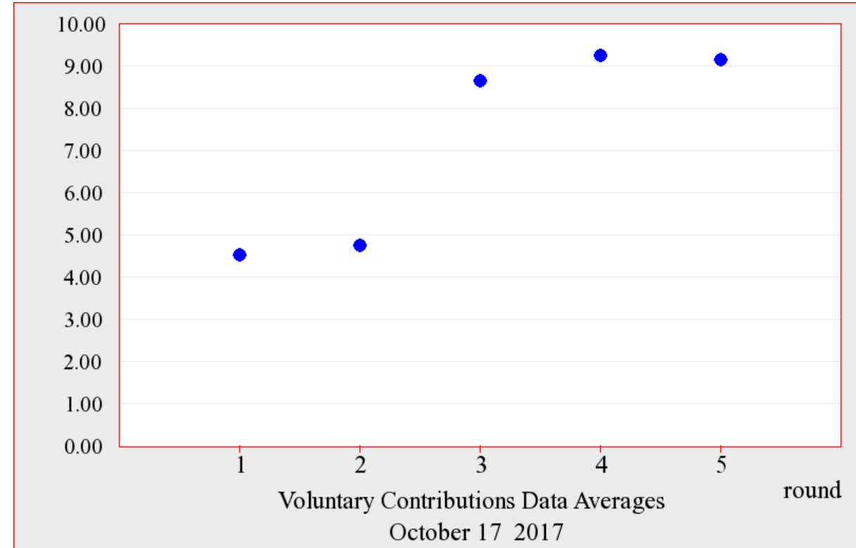

Voluntary Monetary contribution

ROUND

Public Good

With experimental economics research- choices are monetary. Reiterated by the lecture with Naomi Young. Values of the environment are (attempted to be) monetized.

The in class Public Good exercise was a very basic experiment. You decided contribute or not contribute to the public fund or hold the money in your account. This was not “not hypothetical” because money was attached to your decisions. The class decided to contribute to public good, thinking everyone else may too, or you may have held the money in your account, not trusting that others would contribute.

View the graph of the in class Public Good exercise. What happened in the in-class Public Good exercise?

How is it different than the parable with the priest and the cask of wine?

Why?